**API to create a new user and fetch details from the given Id**

**Create User:**

/account/register

**Request Type: POST**

**Description: This registers a new user.**

|  |  |  |  |
| --- | --- | --- | --- |
| **Parameter** | **Value** | **Description** | **Type** |
| first_name | String | first name for registration | Required |
| last_name | String | Last name for registration | Required |
| password | String | Password for registration | Required |
| email | String(standard email format) | Email for registration | Required |

every time a new user registers an authentication token is created for the user.

1. **New User Created Successfully**

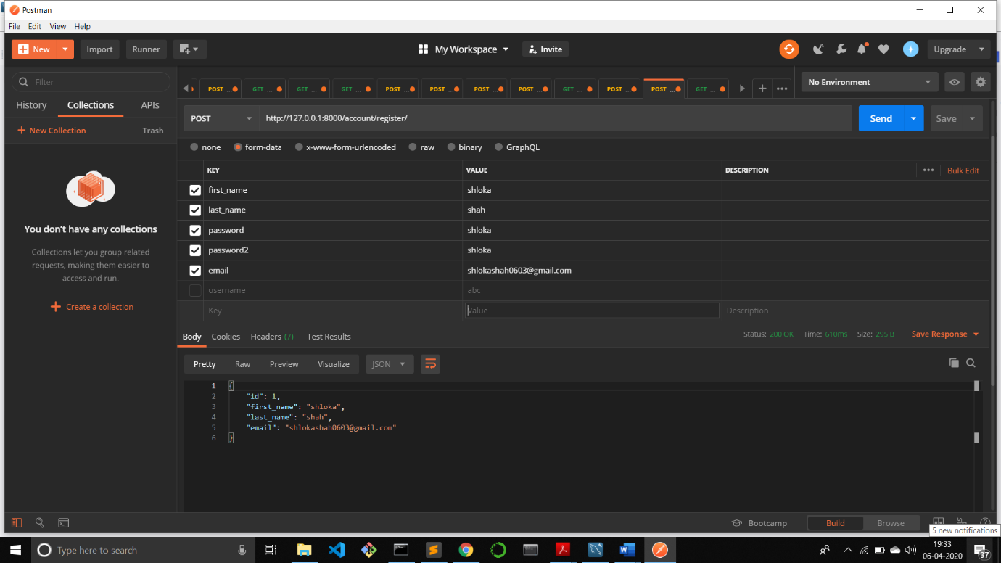

**2)Error if you try registering with the same email id**

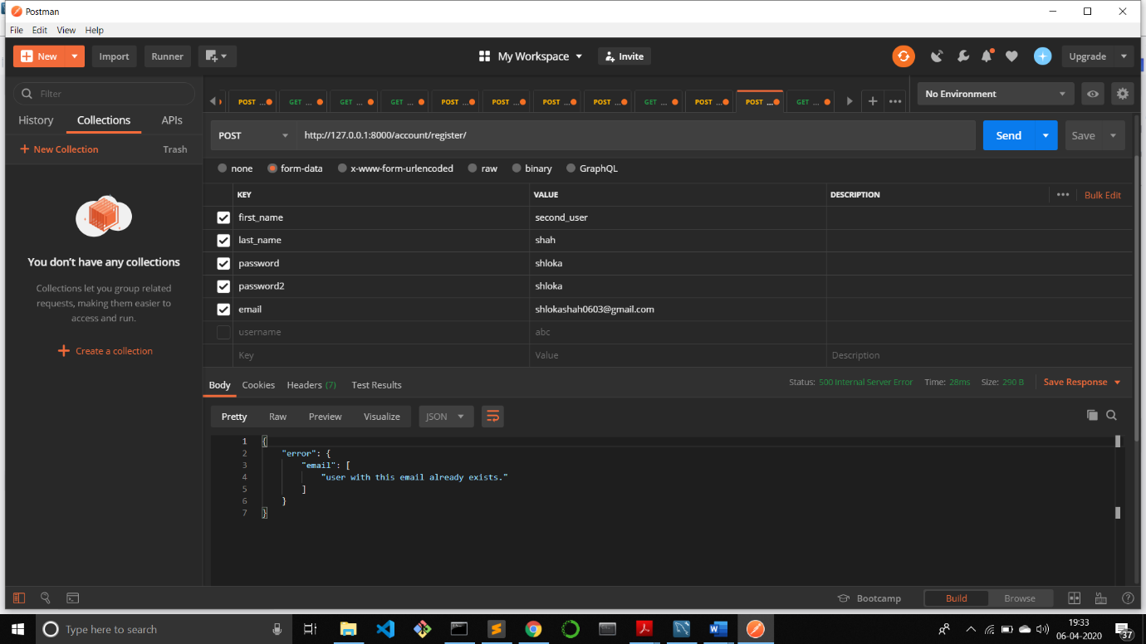

**Fetch User:**

/account/user_details

**Request Type: GET**

**Description: This returns the details of the user: first_name, last_name, email and the id also for a given id in the json format.**

**1)Fetching User Details from the ID Successful**

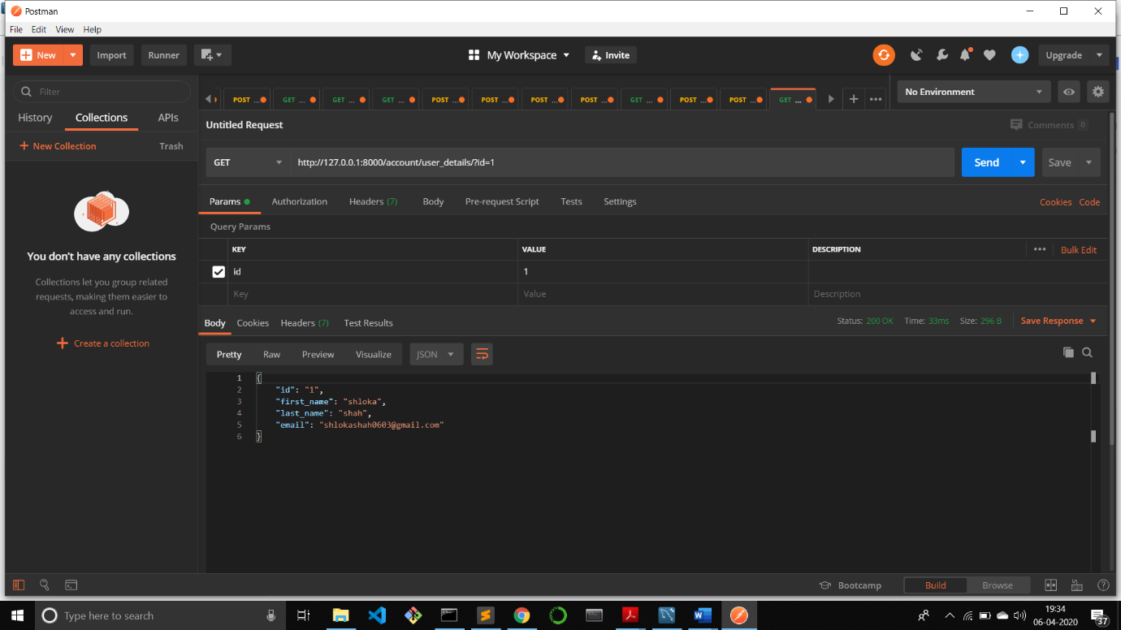

**2)Error Displayed if the User Id passed does not exist in database**

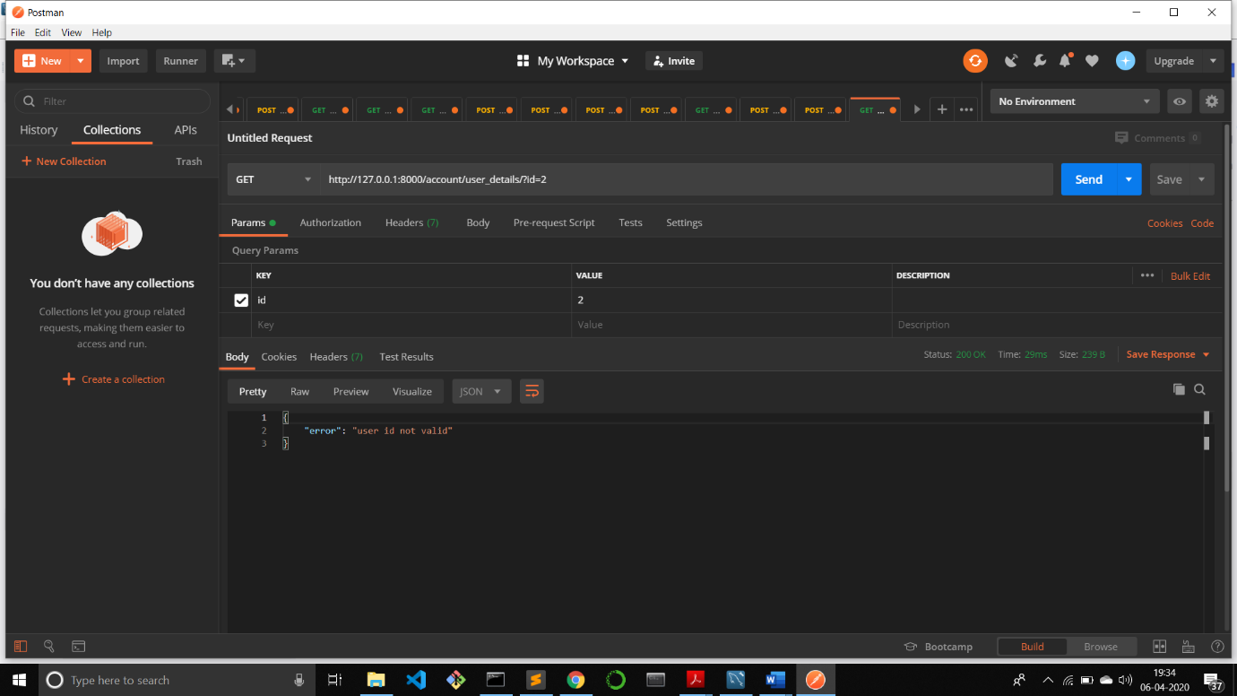

I have used the Django REST Framework.

The database used is mysql.

**The User Table**

